Model Aeronautics
Association of Canada
Unit 9, 5100 South Service Road
Burlington, ON L7L 6A
Attn: Linda Patrick cc Ed Smith, FAI Committee Chairman
Hi Linda,
The F2B Team Trials were conducted on Saturday September 14th at Crowland Park in Niagara Falls Ontario. Crowland Park features an extremely nice paved control line circle located in an area free of trees and buildings that can cause turbulence.
The Team Trials were conducted using the current FAI rules by CD John McFayden 14681L and judging was done by three experienced F2B competitors namely Dave Kelly 3070, Geoff Higgs 5521 and Chris Brownhill 3797L. Tabulator was Naomi Macklem 82384.
There were 4 entrants in the Team Trials, Konstantin Bajaikine 61045, Kim Doherty 32008, Peter Hanson 65002 and John McFayden 14681L.
Each competitor completed 3 official flights. The weather conditions were ideal with full sun and gentle wind.
The results were as follows:
Pilot | Flight 1 | Flight 2 | Flight 3
Peter Hanson | 141.56 | 147.8 | 149.5 | 1 st
Konstantin Bajaikine | 144.06 | 144.7 | 146.76 | 2 nd
Kim Doherty | 139.13 | 141.5 | 141.93 | 3 rd
John McFayden | 124.63 | 133.66 | 137.93

Enclosed is a cheque for $100 for the FAI Travel Fund collected at this event.
Respectfully submitted,

John McFayden 14681L
Committee Chair, Control Line Precision Aerobatics
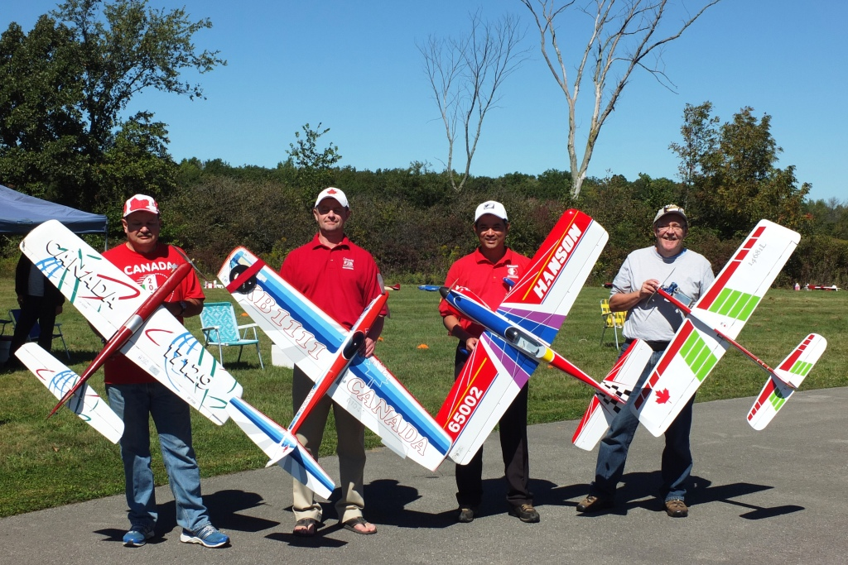
Left to Right : Kim Doherty, Konstantin Bajaikine, Peter Hanson, John McFayden
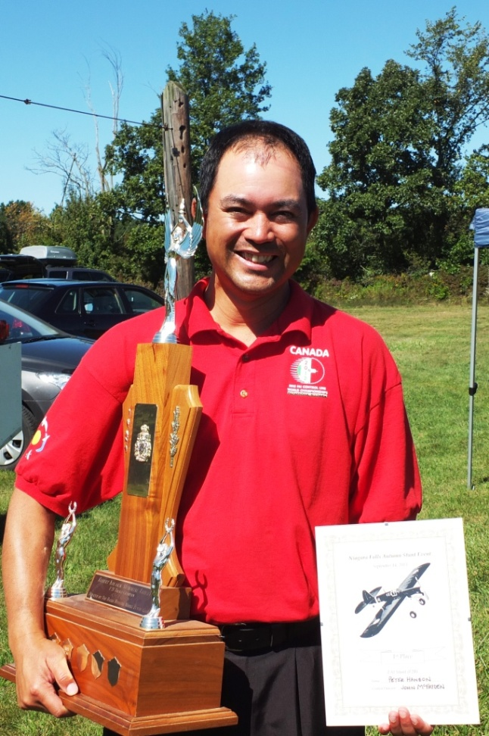

Peter Hanson, a well deserving winner of the 2013 F2B Team Trials.

